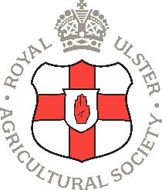

Royal Ulster Agricultural Society
Assistant Steward – Expression of Interest Form
Thank you for your interest in joining us as an Assistant Steward with the Royal Ulster Agricultural Society (RUAS). Please take a few moments to complete all sections of this form.

1. Personal Details
- Full Name: ____________________________________________
- Date of Birth: __________________________________________
- Email Address: _________________________________________
- Phone Number: ________________________________________
- Home Address: _________________________________________
______________________________________________________
______________________________________________________

2. Eligibility
- Are you over 18 years old?
☐ Yes ☐ No

3. About You
- Tell us a bit about yourself (e.g. hobbies, work, studies, etc.):

__________________________________________________________________________________________________________________________________________
- Tell us why you are interested in stewarding and what you hope to gain from the experience:

- Outline any previous experience you may have in stewarding or similar volunteer roles (if any):

4. Availability
- Are you available to steward during Balmoral Show 13th – 16th 2026?
☐ Yes ☐ No ☐ Unsure

5. Induction Day
- Please indicate your availability to attend an Induction Day on either
Saturday 24th January 2026
☐ Yes ☐ No
Or
Saturday 31st January 2026
☐ Yes ☐ No

Declaration
I understand that submitting this form does not guarantee selection.
Signature: _____________________________ Date: ______________

