Private & Confidential

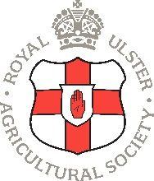
ROYAL ULSTER AGRICULTURAL SOCIETY

MONITORING QUESTIONNAIRE
Ref No: (2025/08/GO/____)

We are an Equal Opportunity Employer. We do not discriminate on grounds of religious belief or political opinion. We practice equality of opportunity in employment and select the best person for the job.
To demonstrate our commitment to equality of opportunity in employment we need to monitor the community background of our employees, as required by the Fair Employment (NI) Order 1998.
Regardless of whether we practice religion, most of us in Northern Ireland are seen as either Catholic or Protestant. We are therefore asking you to indicate your community background by ticking the appropriate box below.
I am a member of the Protestant community
I am a member of the Roman Catholic community
I am a member of neither the Protestant nor Roman Catholic community
Could you please indicate whether you are: Female Male

If you do not complete this questionnaire, we are encouraged to use the “residuary” method which means that we can make a determination on the basis of personal information on file/application form.
Note: It is a criminal offence under the legislation for a person to “give false information…In connection with the preparation of the monitoring return”.

